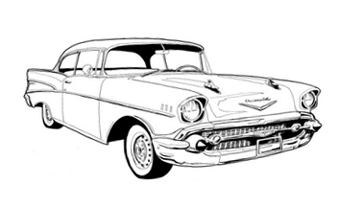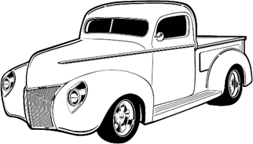
Car Show
Calling all cars, classic and modern
Saturday, 8 June 2024
St. Mary’s County Fairgrounds, Leonardtown, Md.
Show is part of St. Mary’s County annual Crab Festival

Trophies for 1st, 2nd, and 3rd place cars
Plaques for next 15 best cars
Dash Plates for first 35 cars

Car show will be from 11 am with awards given at 3 pm. Registration closes at 12 am.
Proceeds benefit Leonardtown Lions Club charity account

For more information, contact Mike Payne, email payneml@md.metrocast.net
Registration Fee is $20 at the gate and pre-registration is $15. Includes admission fee for driver.
Pre-registration form and check must be received by June 3, 2024.
Make Checks payable and mail to: Leonardtown Lions Club Crab Festival, PO Box 363, Leonardtown, Md. 20650

Name: Club Affiliation:
Address: Vehicle Make:
City/State/Zip: Model:
Phone Number: Year:
Email Address:
Liability: In acceptance to the right to participate, I hereby release the Leonardtown Lions Club, Inc. and everyone connected with management or presentation of this event from any and all known and unknown liabilities that may be suffered by my party (myself, my property, and those persons accompanying me to this event). I further will ensure that my party will observe and obey all safety and traffic regulations, fire ordinances, and will maintain conduct befitting a representative of the Street Rodding Sport. I am aware that said management will do all in its power to safeguard the persons and property involved in this event and to cooperate with participants/spectators to ensure a successful event.
Signature:

